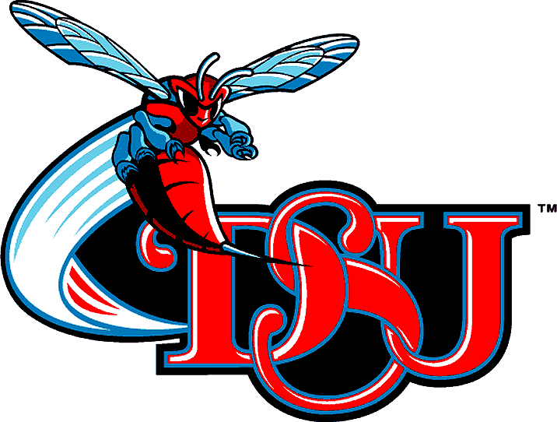Feel The Sting!

Delaware State University held their 6th annual Hornet Day for prospective students on November 15, 2013. Hornet Days were created to give high school seniors the opportunity to experience what it’s like to be a student at Delaware State University. Forty Dover High School seniors attended this event and The Delaware State University staff was impressed with the quality of our students. The seniors toured the campus, spoke directly to admissions counselors, meant student leaders and saw Greek Organizations stroll. Several Dover High students were accepted on the spot! Needless to say, it was fun filled day to remember!

Tis’ the Season for Gift Giving

This year Communities In Schools will collaborate with several community partners to help facilitate the 4th annual Operation Christmas Wish. Operation Christmas Wish brings out local community partners to selected locations where people can adopt families in need. Volunteers then purchase gifts, including clothes, shoes, necessities and non-electronic gifts to be presented anonymously to students and families this holiday season. The gifts are collected and organized by volunteers. The packages are then picked up and stored with the help of our partners at Two Men and a Truck. There are 78 families in the Capital School District to be adopted. Join Communities In Schools on December 14, 2013 at the Dover Mall to adopt one of our families.

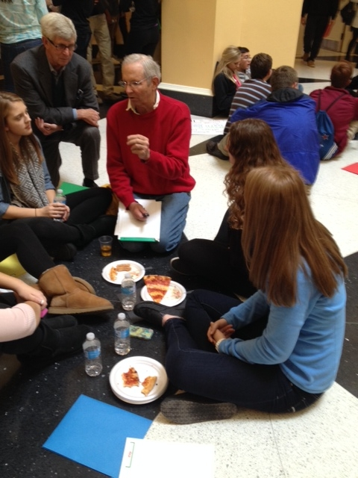Leaders In Training

The Jefferson Awards Organization was co-founded in 1972 by Jacqueline Kennedy Onassis, U.S. Senator Robert Taft, Jr. and Sam Beard, as the 'Nobel Prize' for public service. Today, the mission of the Jefferson Awards is to recognize, inspire and activate volunteerism and public service in communities, workplaces and schools across America. On November 23, 2013 six Dover High student leaders attended the Jefferson Award Leadership Conference at the University of Delaware. Student leaders from UD presented various workshops on topics such as entrepreneurship, leadership skills and smart goals. Dover High students also participated in service learning activities that addressed hunger and poverty.
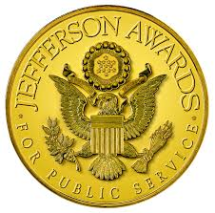DHS students conversing with Sam Beard, founder of the
Jefferson Awards for Public Service.

Community Partner Spotlight

Communities In Schools would like to give a special thank you to the Delaware Breast Cancer Coalition and The DHS Community Resource Center for an excellent collaboration that allowed students and their families to learn about breast health. We love the work we do and community partners like you make it easier

Patience Bowman
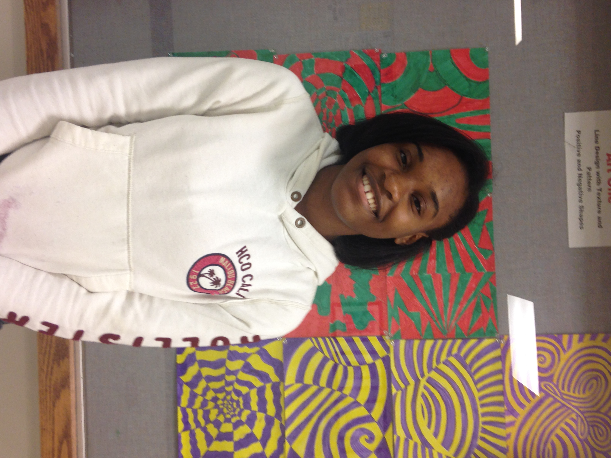

Patience Bowman is a 17
year old senior at Dover
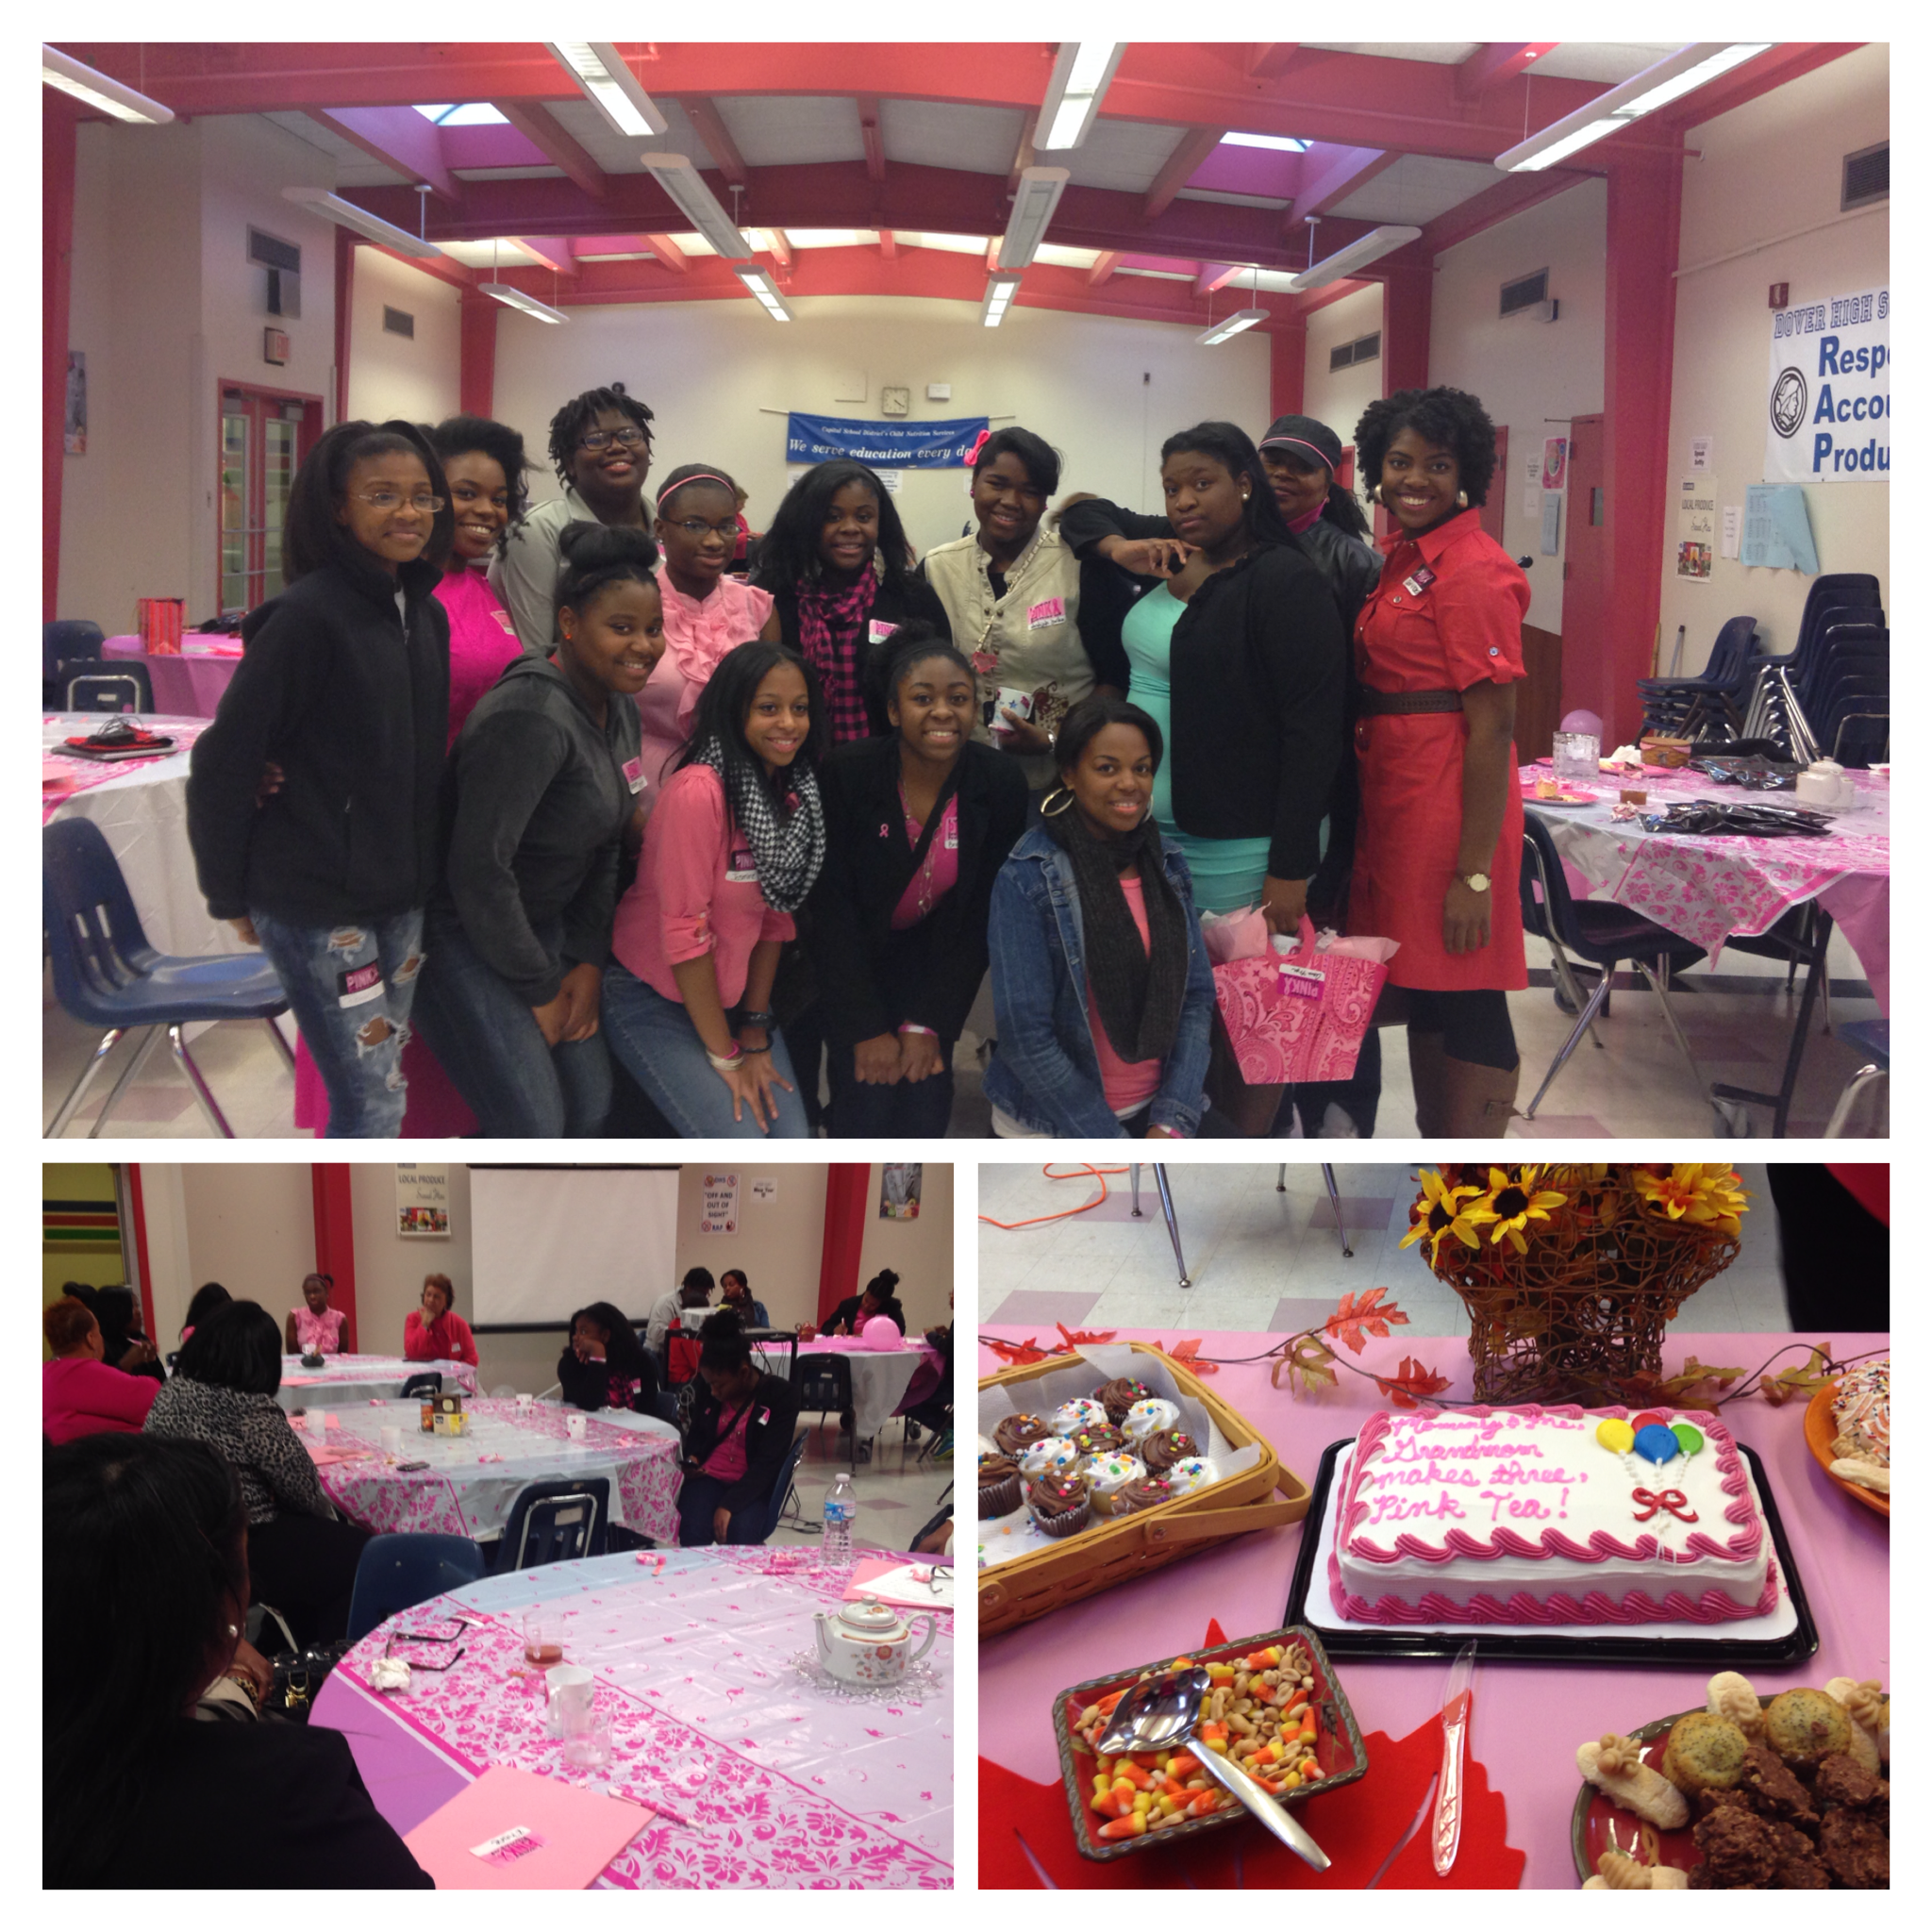High School. She enjoys playing sports and has participated in indoor and outdoor track for a few years. Ms. Bowman is on the choir in her church and also volunteers with different organizations within her community. Next Fall Ms. Bowman will be a Freshmen at Delaware Technical Community College with a major in Social Work.

Mommy & Me, Grand mom Makes Three,
Pink Tea
The Delaware Breast Cancer Coalition teamed up with Communities In Schools and The Dover High School Parent Resource Center to host a wonderful pink tea party on Saturday, November 23, 2013. The event began with a fun icebreaker and informative truth or myth activity. Next, the breakout sessions began! Youth and adults were separated into groups to discuss different breast health topics such as mammograms, early detection, and normal breast development. Several members of the girls group Building Fabulous Futures (B.F.F) attended this event with their mothers and grandmothers.
Site Director: Terisha Collins
tcollins@cisdelaware.org; Terisha.collins@capital.k12.de.us
302.672.1525 ext.2573

Site Coordinator: Sashalee King, Public Ally
sking@cisedelaware.org; sashalee.king@capital.k12.de.us

