Basic 1: A One on One Relationship with a Caring Adult
In alignment with one of Communities in Schools of Delaware’s (CISDE) core values, fostering one on one caring student/adult relationships, student mentoring is utilized throughout CISDE sites statewide. The format varies according to location and student age but focuses on bolstering academic skills, providing support and encouragement, building plans for the future, connecting students to resources, and developing social abilities. CISDE has facilitated quality mentoring, aligning with MENTOR’s “best practices” at the following schools: Dover High, Campus Community Charter, Milford Central Academy, Newark High, William Penn High, McKean High, East Side Charter, and AI Middle.

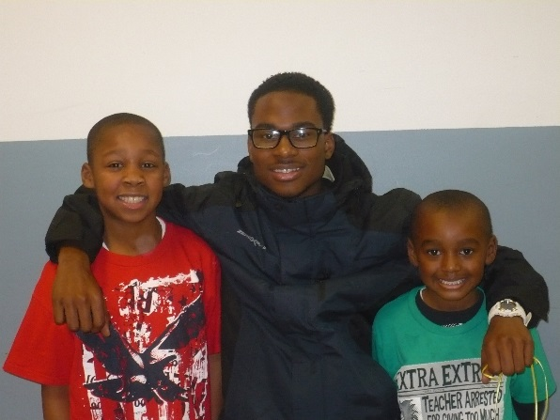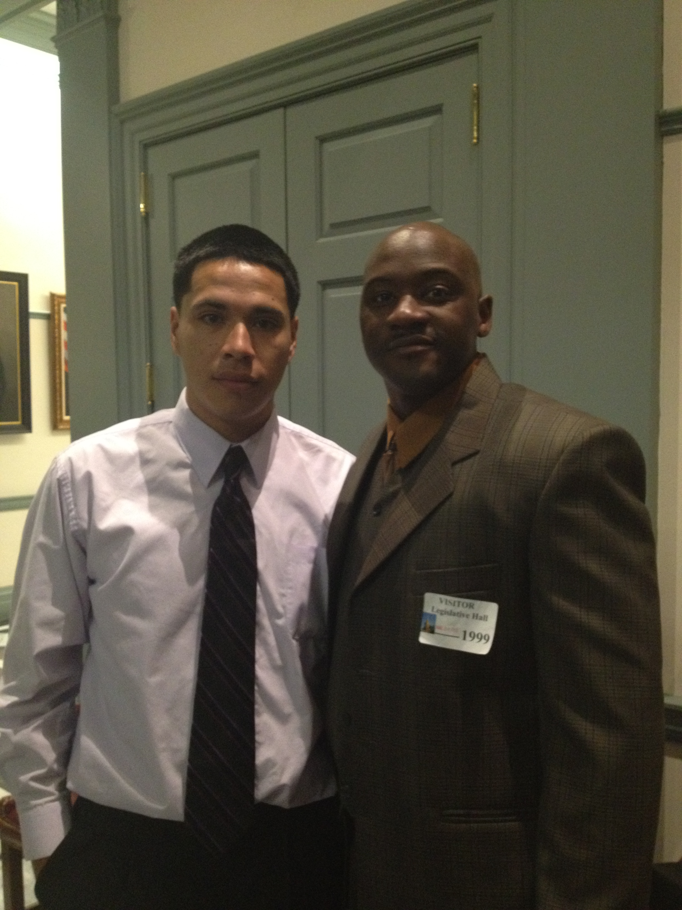

CISDE collaborates with several partners to facilitate effective, impactful, and efficient mentoring initiatives in Delaware. Schools and districts, Connecting Generations, the Capital Mentors program, the Greater Dover Committee, and Barclay’s Bank are among our key partners for the 2012-2013 school year. Additionally, several businesses and organizations throughout the state have encouraged the participation of employees as mentors. CISDE paired 275 community members with students, totaling more than 3415 quality mentoring hours. Ashland, Capital One, Delaware State University, Kraft Foods, and Proctor and Gamble are among these organizations.

School Highlights:
Dover High: 30 students spent 265 quality hours with adult mentors, focusing on personal development and future preparation. 22 Dover High students met with elementary students at a neighboring school for 200 hours, where students learned the importance of good decisions and positive behavior.
Campus Community School: 55 students met weekly with adults to discuss positive actions and future planning. 25 students mentored younger students in the building and planned cultivating positive relationships, one-on-one skill development, and friendship.
East Side Charter School: 111 students, meeting with mentors for more than 2060 hours combined, focused on improving academic achievement and commitment to education.

*Students randomly selected | Mentored Students (N=75) | Control Group (N=75) |  | Dover High Mentored (N=25) | Dover High Control Group (N=25) | Campus Community Mentored (N=25) | Campus Community Control Group  (N=25) | East Side Charter Mentored (N=25) | East Side Charter Control Group (N=25)
Improve: Overall Academics | 93% | 85% |  | 88% (22) | 72% (18) | 100% | 96% (24) | 92% (23) | 88% (22)
Improve: Overall Attendance | 76% | 53% |  | 56% (14) | 63% (15) | 100% | 44% (11) | 72% (18) | 56% (14)
Improve: Commitment | 91% | 85% |  | 100% (25) | 100% (25) | 100% | 84% (21) | 72% (18) | 72% (18)
Improve: Behavior | 89% | 62% |  | 100% (25) | Not measured | 88% (22) | 56% (14) | 80% (20) | 68% (17)
Promoted to next grade or graduated | 96% | 92% |  | 92% (23) | 84% (21) | 96% (24) | 92% (23) | 100% | 100%

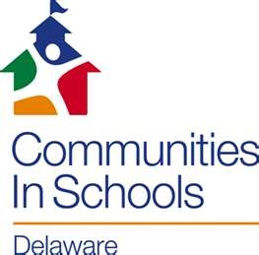

CISDE believes every child deserves:
-A one on one relationship with a caring adult
-A safe place to learn and grow
-A healthy start and future
-A marketable skill to use upon graduation
-A chance to give back to community

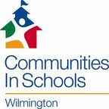

The mission of Communities in Schools in Delaware is to surround students with a community of support, empowering them to stay in school and achieve in life.

