Welcome Back
Communities In Schools will like to welcome back the entire faculty, staff and most importantly, THE STUDENTS! We are excited for this upcoming school year that will be filled with events, trips, programs and new adventures. Communities In Schools will continue working hard to provide resources for our students. We are pleased with our previous results and plan to expand our student base. We will continue to collaborate with the community and school staff to develop quality initiatives at Dover High School.

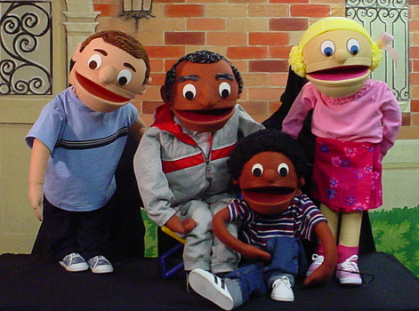Kids on the Block
Kids on the Block is sponsored by the Governors Advisory Counsel for Exceptional Citizens. High school students perform puppet shows for junior high and elementary school students about difficult topics such as the following: cerebral palsy, childhood cancer and HIV/AIDS, educational differences including learning disabilities and ADHD, and social concerns including sexual abuse prevention, and alternatives to violence. Dover High School students will be participating in Kids on the Block this year. They have begun their practices with the instructors once a week.

B.F.F first meeting (Building Fabulous Futures)...…………October 10, 2013
Dress To Impress (Homecoming Dresses)........................October 16-24, 2013
Temple University College Tour………………………..October 17, 2013

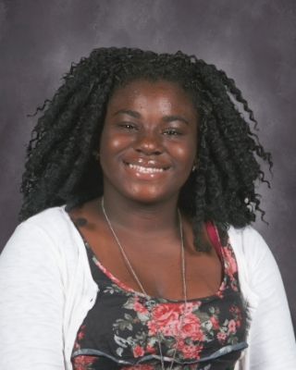
Name: Amber Dyer
Age: 15
Activities: 21st Century, Mentor

Amber Dyer is currently a sophomore here at Dover High School. She has been involved with the mentoring program since she was a student at Central Middle School. When asked about the relationship with her mentor Amber stated, “My mentor is a nice person to talk to; my acamedic life has improved because of her and my involvemnet with Communities In Schools. Amber wishes to attend Delaware State University and follow the footsteps of her god mother as a Correction Officer.

Community Partner Spotlight
Communities In Schools would like to give a special thank you to Kids on the Block, Inc for allowing our students to participate in such creative and powerful program. Your time is greatly appreciated. We love the work we do and community partners like you make it easier!

Site Director: Terisha Collins
tcollins@cisdelaware.org; Terisha.collins@capital.k12.de.us
302.672.1525 ext.2573

Site Coordinator: Sashalee King, Public Ally
sking@cisedelaware.org; sashalee.king@capital.k12.de.us
302.672.1525 ext. 2573

